Course: 113-1 Embedded Systems

Assignment 3: **Shell Scripting**

**Student No: 113598043**

**Student Name: 張育丞**

### Practice: New Year Calculator.

**Please create a program that can be used to calculate "how many days do you have to celebrate the New Year” ?**

**The program will calculate #days remaining to the next new year (YYYY-01-01).**

1. Create a file called newyear.sh or whatever you want using vi / vim.
2. Write shell script inside that file.
3. Save the file, executing it using Bash.

**Example output:**

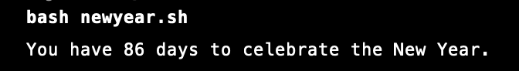

**Please put your answers in the ANSWER AREA below.**

Script: the shell script program itself.

Image: the screenshot / picture of the running result.

|  |  |
| --- | --- |
| **ANSWER AREA** | |
| **Script** |  |
| **Result** |  |